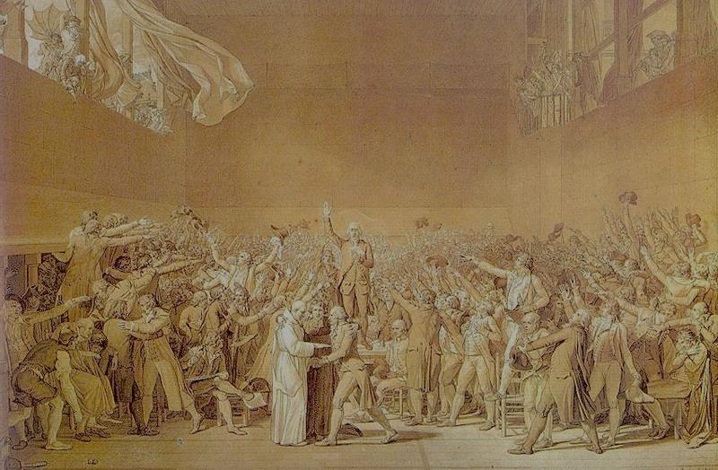

French Revolution

Final Assessment

Using the information gathered from your research of the French Revolution, evaluate the validity of the following statement:

The French Revolution corresponds to the model presented in Brinton’s The Anatomy of a Revolution.

Be certain to include several examples to justify your position.

