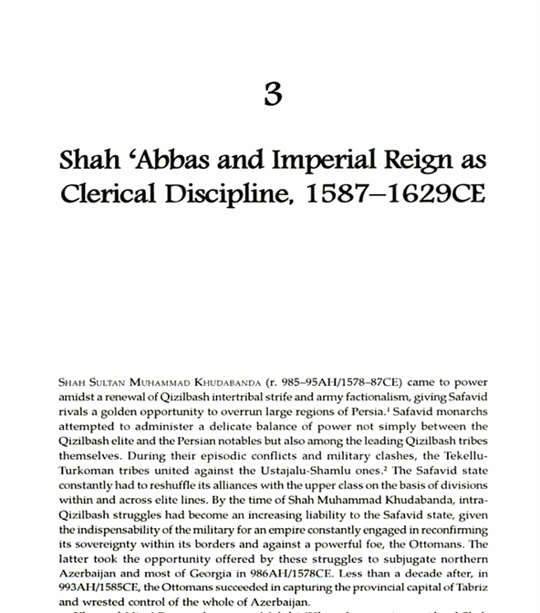
DOCUMENT 1

DOCUMENT 2

Indian History Sourcebook:
François Bernier:
An Account of India and the Great Moghul, 1655 CE

He who reigned there was called Chah-Jehan [i.e., Shah Jahan], ---that is to say, king of the world; who, according to the history of that country, was son of Jehan-Guyre [i.e., Jahangir], which signifies conqueror of the world; grandchild to Ekbar [i.e., Akbar], which is great; and thus ascending by Houmayons, or the fortunate, father of Ekbar, and his other predecessors, he was the tenth of those that were descended from Timur-Lengue [i.e., Timur Lang] which signifies the lame prince, commonly and corruptly called Tamerlane, so renowned for his conquests; who married his near kinswoman, the only daughter of the prince of the nations of Great Tartary, called Moguls, who have left and communicated their name to the strangers that now govern Indostan, the country of the Indians; though those that are employed in public charges and offices, and even those that are listed in the militia, be not all of the race of the Moguls, but strangers and nations gathered out of all countries, most of them Persians, some Arabians, and some Turks. For, to be esteemed a Mogul it is enough to be a stranger, white of face, and a Mohammedan; in distinction as well to the Indians, who are brown and pagans, as to the Christians of Europe, who are called Franguis [i.e., "Ferengis" or "Franks"]. . . .

DOCUMENT 3

In directing his son to continue the administrative policies set forth by Sheik Edebali, Osman stated:
Son! Be careful about the religious issues before all other duties. The religious precepts build a strong state. Do not give religious duties to careless, faithless and sinful men or to dissipated, indifferent or inexperienced people. And also do not leave the state administrations to such people. Because the one with fear of God the Creator, has no fear of the created. One who commits a great sin and continues to sin can not be loyal. Scholars, virtuous men, artists and literary men are the power of the state structure. Treat them with kindness and honour. Build close relationship when you hear about a virtuous man and give wealth and grant him...Put order the political and religious duties. Take lesson from me so I came to these places as a weak leader and I reached to the help of God although I did not deserve. You follow my way and protect [Islam] and the believers and also your followers. Respect the right of God and His servants. Do not hesitate to advise your successors in this way. Depend on God's help in the esteem of justice and fairness, to remove the cruelty, attempts in every duty. Protect your public from enemy's invasion and from the cruelty. Do not behave any person in an unsuitable way with unfairness. Gratify the public and save all of their sake.
DOCUMENT 4
Islamic History Sourcebook:
James M. Ludlow: The Tribute of Children, 1493

[Tappan Introduction] ABOUT a century before the capture of Constantinople, when Amurath I was on the throne, his vizier suggested to him that he had a right not only to one-fifth of the spoils of battle, but also to one-fifth of the captives. "Let officers be stationed at Gallipoli," he said, "and as the Christians pass by, let them choose the fairest and strongest of the Christian boys to become your soldiers." Thus was formed the famous corps of the Janizaries. To keep it up, the agents of the sultan went once in four years to all the Christian villages under Turkish control. Every boy between six and nine years of age must be brought before them, and the agents carried away one-fifth of the number, carefully selecting the strongest and most intelligent.
THE advice of the vizier was followed; the edict was proclaimed; many thousands of the European captives were educated in the Mohammedan religion and arms, and the new militia was consecrated and named by a celebrated dervish. Standing in the front of their ranks, he stretched the sleeve of his gown over the head of the foremost soldier, and his blessing was delivered in the following words "Let them be called Janizaries [yingi-cheri--or "new soldiers"]; may their countenances be ever bright; their hand victorious; their swords keen; may their spear always hang over the heads of their enemies; and, wheresoever they go, may they return with a white face." White and black face are common and proverbial expressions of praise and reproach in the Turkish language. Such was the origin of these haughty troops, the terror of the nations.
They are kept up by continual additions from the sultan's share of the captives, and by recruits, raised every five years, from the children of the Christian subjects. Small parties of soldiers, each under a leader, and each provided with a particular firman, go from place to place. Wherever they come, the protogeros assembled the inhabitants with their sons. The leader of the soldiers have the right to take away all the youth who are distinguished by beauty or strength, activity or talent, above the age of seven. He carries them to the court of the grand seignior, a tithe, as it is, of the subjects. The captives taken in war by the pashas, and presented by them to the sultan, include Poles, Bohemians, Russians, Italians, and Germans.

DOCUMENT 5

Jewish History Sourcebook:
Islam and the Jews: The Status of Jews and Christians in Muslim Lands, 1772 CE

In 1772 a Muslim scholar in Cairo was asked how Jews and Christians should be treated. The answer is found in this selection, issued four years before the American Declaration of Independence. This answer is not law, but only the opinion of a conservative Muslim. The opinion is in Arabic.

The Answer Of The Shaikh Hasan Al Kafrawi, The Shafiite [Professor of canon law in Cairo, d. 1788 CE]

Praise be to God, the guide of the right way!

The decision given by the Shaikh ar-Ramli [a great Cairo legal authority, d. 1596], by the Shaikh al-Islam [the Muslim religious authority in Constantinople], and by the learned scholars whose decrees can hardly be written down here, may be worded as follows: "It is forbidden to the tolerated peoples living on Muslim territory to clothe themselves in the same manner as the chiefs, the scholars, and the nobles. They should not be allowed to clothe themselves in costly fabrics which have been cut in the modes which are forbidden to them, in order that they may not offend the sensibilities of poor Muslims and in order that their faith in their religion should not be shaken by this. [Poor Muslims may regret their faith when they see how well-dressed the Christians and Jews are.]

"They should not be permitted to employ mounts like the Muslims. They must use neither saddles, nor iron-stirrups, in order to be distinguished from the true believers. They must under no circumstance ride horses because of the noble character of this animal. The Most-High has said [Qu'ran 8:62]: 'And through powerful squadrons [of horses] through which you will strike terror into your own and God's enemies.' [A verse of the Qu'ran makes a good support for a law. Verses may even be torn out of their context.]

"They should not be permitted to take Muslims into their service because God has glorified the people of Islam. He has given them His aid and has given them a guarantee by these words [Qu'ran 3:140]: 'Surely God will never give preeminence to unbelievers over the true believers.' Now this is just what is happening today, for their servants are Muslims taken from among men of a mature age or from those who are still young. This is one of the greatest scandals to which the guardians of authority must put an end. It is wrong to greet them even with a simple 'how-do-you-do'; to serve them, even for wages, at the baths or in what relates to their riding animals; and it is forbidden to accept anything from their hand, for that would be an act of debasement by the faithful. They are forbidden while going through the streets to ape the manners of the Muslims, and still less those of the cities of the religion. They shall only walk single-file, and in narrow lanes they must withdraw even more into the most cramped part of the road.

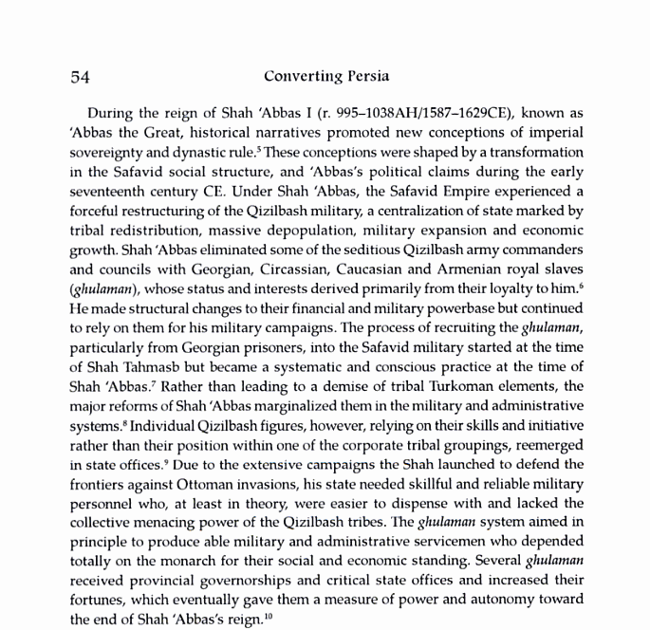
DOCUMENT 6

DOCUMENT 7
In 1582, King Philip II of Spain received a letter from the Mughal Emperor Akbar of India.
Akbar wrote: "As most men are fettered by bonds of tradition, and by imitating ways followed by their fathers... everyone continues, without investigating their arguments and reasons, to follow the religion in which he was born and educated, thus excluding himself from the possibility of ascertaining the truth, which is the noblest aim of the human intellect. Therefore we associate at convenient seasons with learned men of all religions, thus deriving profit from their exquisite discourses and exalted aspirations." [Johnson, 208]

DOCUMENT 8
Jahangir: letter to James I (1617)
Mughal emperor Jahangir wrote this letter to Great Britain's King James I in 1617, recognizing the gifts of the English envoy to his court and opening some of India's ports to British merchants. Such access was the beginning of British influence in India, led by the British East India Company. The Portuguese and French also established trading relations with the Mughal rulers. Within a century and a half of this letter, the Mughal Empire would be destroyed, and Britain would establish its predominance over the Indian subcontinent.
When your Majesty shall open this letter let your royal heart be as fresh as a sweet garden. Let all people make reverence at your gate; let your throne be advanced higher; amongst the greatness of the kings of the prophet Jesus, let your Majesty be the greatest, and all monarchies derive their counsel and wisdom from your breast as from a fountain, that the law of the majesty of Jesus may revive and flourish under your protection.
The letter of love and friendship which you sent and the presents, tokens of your good affections toward me, I have received by the hands of your ambassador, Sir Thomas Roe (who well deserves to be your trusted servant), delivered to me in an acceptable and happy hour; upon which mine eyes were so fixed that I could not easily remove them to any other object, and have accepted them with great joy and delight.
Upon which assurance of your royal love I have given my general command to all the kingdoms and ports of my dominions to receive all the merchants of the English nation as the subjects of my friend; that in what place soever they choose to live, they may have free liberty without any restraint; and at what port soever they shall arrive, that neither Portugal nor any other shall dare to molest their quiet; and in what city soever they shall have residence, I have commanded all my governors and captains to give them freedom answerable to their own desires; to sell, buy, and to transport into their country at their pleasure.
For confirmation of our love and friendship, I desire your Majesty to command your merchants to bring in their ships of all sorts of rarities and rich goods fit for my palace; and that you be pleased to send me your royal letters by every opportunity, that I may rejoice in your health and prosperous affairs; that our friendship may be interchanged and eternal.
Your Majesty is learned and quick-sighted as a prophet, and can conceive so much by few words that I need write no more.
The God of heaven give you and us increase of honor.

